**Solutions for Subjective Questions**

1. Which are the top three variables in your model which contribute most towards the probability of a lead getting converted?

The top 3 variables that contribute the most towards the probability of a lead getting converted are:

* Last activity
* Lead source
* What is your current occupation?
* Total Visits

1. What are the top 3 categorical/dummy variables in the model which should be focused the most on in order to increase the probability of lead conversion?

the top 3 categorical/dummy variables in the model which should be focused the most on in order to increase the probability of lead conversion include:

* lead sorce_welingkakwebiste
* What is your current occupation_Working Professional
* Last Activity_Olark Chat Conversation

1. X Education has a period of 2 months every year during which they hire some interns. The sales team, in particular, has around 10 interns allotted to them. So during this phase, they wish to make the lead conversion more aggressive. So they want almost all of the potential leads (i.e. the customers who have been predicted as 1 by the model) to be converted and hence, want to make phone calls to as much of such people as possible. Suggest a good strategy they should employ at this stage.

**Strategy for Aggressive Lead Conversion (Interns Period):**

**Prioritize High-Probability Leads:**

During the intern period, the focus should be on high-probability leads predicted by the model (leads with a high lead score). The model should have a threshold set to identify leads with a high likelihood of conversion, which is 8.

Threshold Adjustment: Instead of a strict 0.8 threshold for "hot leads," consider lowering it temporarily to 0.7 or 0.65. This will capture more potential leads while maintaining a decent conversion rate.

Priority Queuing: Within the lowered threshold pool, prioritize leads based on additional factors like lead score, time since conversion prediction, or specific course interest. This ensures maximum efficiency for the intern team.

Automation & Delegation: Utilize automated email sequences or chatbot interactions for lower-scoring leads within the aggressive threshold. This frees up the intern team for high-potential calls.

Increase Communication Channels: Apart from phone calls and emails (many people opt out of it) explore other communication channels like live chat, automated chat, SMS, or even targeted advertisements for the identified high-probability leads.

* we can see more converted leads as the total time spent on the website increases (above 600 minutes for converted leads). They typically have 1 to 6 page views per visit on the website

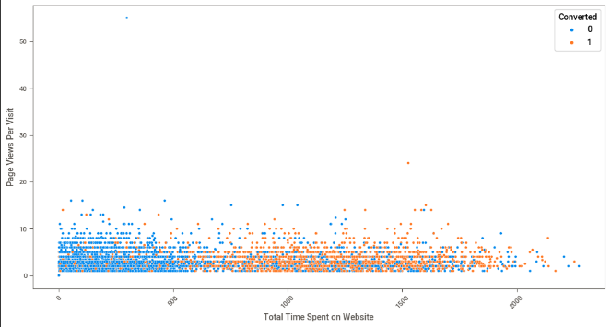

* Most converted leads come from people who have opted out of email than the ones who have opted for it. The majority of the people opt out of email, hence it's not advisable to focus much on emails.

* Landing Page Submission has the highest conversion rate and the lead ad form is the lowest conversion. Interns can focus on making landing page forms easy and API-based conversions and work on improving lead ad form conversions

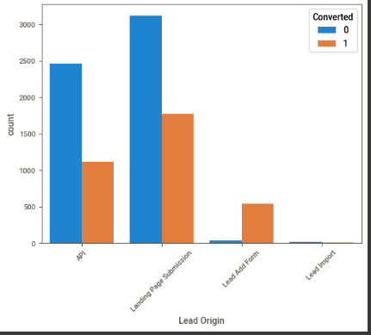

* There are more conversions for Total time spent on the website than non-converted leads. Around 1300 conversions and 400 non converted leads

* As we can see, the highest converted leads and total visits for Google, Direct Traffic and Reference. Reference has the most converted leads and negligible non converted leads out of all the categories. We can see the highest non-converted leads and total visits for Direct Traffic. The interns should focus on Google, Direct Traffic and Reference as lead sources and try to nurture them into the funnel.

* The interns should focus on SMS as most converted leads are active from SMS ad the most non-converted ones from email.

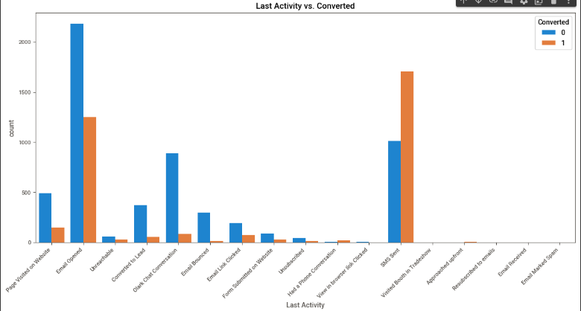

* Customized Communication Scripts: Provide interns with customized communication scripts for different segments of high-probability leads. Tailor the messaging based on the lead's characteristics and behavior, such as occupation, etc. Most converted leads are unemployed and the motive behind taking up a course is job prospects as shown in graphs and data visualization below.

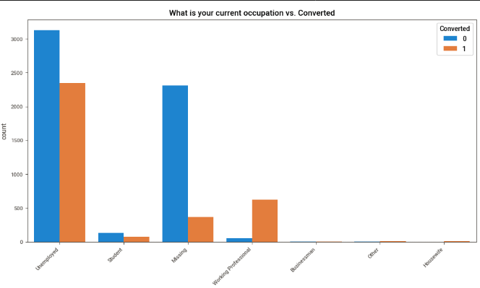

* As we can see most of the leads(converted and non-converted have less than 40 total visits on the website. Most of the leads have less than 20 total visits. We can see that most converted leads have less than 20 Total visits and spend more than 600 minutes on thewebsite.e

* Spending time on freebies, such as infographics or ePDFs should be productive. People are currently not getting converted with infographics or ebooks . Either one has to change the topic to a more relevant one or find another way to convert

Time-Sensitive Offers: Create time-sensitive offers for high-probability leads to encourage faster conversions. Limited-time discounts or special promotions can incentivize quicker decision-making.

Intern Training: Conduct training sessions for interns to enhance their communication and persuasion skills. Emphasize the importance of understanding customer needs and addressing concerns effectively.

1. Similarly, at times, the company reaches its target for a quarter before the deadline. During this time, the company wants the sales team to focus on some new work as well. So during this time, the company’s aim is to not make phone calls unless it’s extremely necessary, i.e. they want to minimize the rate of useless phone calls. Suggest a strategy they should employ at this stage.Goal: Minimize unnecessary calls while maintaining conversion momentum.

1. Focus on Alternative Engagement Channels:

* Automated Email Sequences: Utilize pre-designed email sequences based on lead segments or conversion stages. These can provide valuable information, nurture leads, and keep them engaged without requiring immediate phone calls.
* Webinars and Online Events: Organize targeted webinars or online events focused on specific courses or specializations. This allows for efficient engagement with a larger audience without individual phone calls.
* Personalized Content and Recommendations: Leverage website data and lead scores to personalize website content and recommend relevant courses or resources. This keeps leads engaged and informed without requiring active sales intervention.
* Most converted leads come from people who have opted out of email than the ones who have opted for it. The majority of the people opt out of email, hence it's not advisable to focus much on emails.

* Landing Page Submission has the highest conversion rate and the lead ad form is the lowest conversion. Interns can focus on making landing page forms easy and API-based conversions and work on improving lead ad form conversions



* There are more conversions for Total time spent on the website than non-converted leads. Around 1300 conversions and 400 non converted leads
* A diagram of a graph

  Description automatically generated with medium confidence
* As we can see, the highest converted leads and total visits for Google, Direct Traffic and Reference. Reference has the most converted leads and negligible non converted leads out of all the categories. We can see the highest non-converted leads and total visits for Direct Traffic. The interns should focus on Google, Direct Traffic and Reference as lead sources and try to nurture them into the funnel.

* The interns should focus on SMS as most converted leads are active from SMS ad the most non-converted ones from email.



Customized Communication Scripts: Provide interns with customized communication scripts for different segments of high-probability leads. Tailor the messaging based on the lead's characteristics and behavior, such as occupation, etc. Most converted leads are unemployed and the motive behind taking up a course is job prospects as shown in graphs and data visualization below.



* Spending time on freebies, such as infographics or ePDFs should be productive. People are currently not getting converted with infographics or ebooks . Either one has to change the topic to a more relevant one or find another way to convert

* we can see more converted leads as the total time spent on the website increases (above 600 minutes for converted leads). They typically have 1 to 6 page views per visit on the website

2. Utilize Data Analysis and Monitoring:

**Insights from the correlation matrix:**

* There is a high correlation between the Lead origin as lead import and the lead source as Facebook.
* There is a high correlation between the Last Activity of the users which was **Unsubscribed**  and the **lead source** which was **Facebook**. It means most people who are unsubscribing are from Facebook. Interns need to focus on Facebook advertising with customized ads and specialized content.
* High correlation between the lead origin in **Ad form category and lead source**, reference category. It simply means the converted leads from **ad form** are **references**.
* High correlation between **Last Activity** column in the **Email Opened** category and **Last Notable Activity** column in the **Email Opened** category. It simply means the customers whose last activity was checking email were most likely to check emails or be active on email as compared to other platforms.
* High correlation between the **Last Activity** column in the **SMS Sent** category and **Last Notable Activity** column in the **SMS Sent category**. It simply means the customers whose last activity was SMS Sent were most likely to check SMS or be active on SMS as compared to other platforms.
* High correlation between **Last Activity** column in the **Email opened** category and Last Activity in the **Email Link Clicked** category. It simply means the customers whose last activity was **Email Link Clicked** were most likely to check emails or be active on emails as compared to other platforms.
* High correlation between the **Last Activity** column in the **Had a Phone Conversation** category and the **Last Notable Activity** column in the **Had a Phone Conversation** category. It simply means the customers whose last activity was **having a phone conversation** were most likely to interact on calls as compared to other platforms.
* High correlation between the **Last Activity** column in the **Email Received** and the **Last Notable Activity** column in the **Email Received** category. It simply means the customers whose last activity was **receiving an email** were most likely to interact on emails as compared to other platforms.

3. Consider Additional Factors:

* Lead Origin and Source: Analyze **lead origin and source columns** data to identify segments that might be more receptive to specific engagement channels
* Lead Nurturing History: Consider past interactions and engagement history with individual leads. Those who have already received significant outreach might benefit from a temporary break from phone calls.
* Identify leads with high lead scores, indicating a higher likelihood of conversion.
* Prioritize Non-Intrusive Channels: During this period, prioritize communication channels other than phone calls for high-scoring leads. Utilize personalized content, and online communication to engage with leads.
* Automated Nurturing Campaigns: Implement automated nurturing campaigns for high-scoring leads. Design a series of targeted emails or content that educates and nurtures leads without the need for direct phone calls.
* Segmentation and Personalization: Segment leads based on their characteristics, behaviors, and preferences. Personalize communication to cater to the specific needs and interests of each segment.
* Utilize Retargeting Ads: Implement online retargeting ads to keep the brand in front of potential customers. Use digital advertising platforms to reinforce the company's offerings without direct phone contact.
* Engage Through Social Media: Leverage social media platforms to engage with leads. Share relevant content, participate in discussions, and respond to queries through social media channels.
* Feedback Loop: Establish a feedback loop with the sales team to gather insights on lead behavior and preferences during this period. Use feedback to refine and optimize the automated nurturing campaigns.
* Pause Outbound Phone Call Initiatives. Temporarily pause outbound phone call initiatives for leads during this period. Focus on inbound inquiries or leads showing explicit interest in receiving phone calls.
* Monitor Conversion Rates: Continuously monitor conversion rates during this period. Evaluate the impact of the strategy on conversion rates and lead engagement.
* Training and Skill Enhancement: Utilize this time to provide additional training and skill enhancement for the sales team.
* Enhance their digital communication skills and ability to nurture leads through non-phone channels.
* Evaluate New Work Opportunities: Identify and explore new areas of work or projects that the sales team can focus on during this period. Diversify efforts to contribute to the company's overall growth.
* Prepare for Resumption of Phone Calls: Anticipate the end of the period and plan for the resumption of phone calls as needed. Ensure the sales team is ready to transition back to regular activities.